5. AI Food Identification Feature

5.1 Overview
The AI Food Identification feature allows users to upload a photo of their meal and automatically detect the food items along with estimated nutritional information. This function helps users quickly log their daily food intake without manual searching.

5.2 How to use the Food Identifier

5.2.1 Access the feature
- Log in to your account
- Click on the “Identifier” tab in the navigation bar
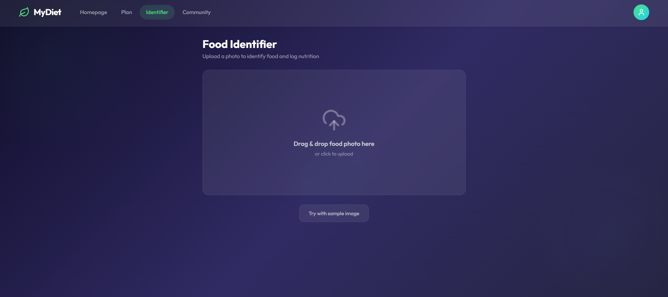

5.2.2 Upload a food image
Users can upload an image in two ways:
- Drag and drop the image into the upload box
- Click the upload area to select a file from the device
Users can also click “Try with sample image” to test the feature.

5.2.3 View recognition results
After uploading, the system will process the image and display:
- A preview of the uploaded image
- A list of detected food items
- Estimated portion size
- Confidence level
- Estimated calories
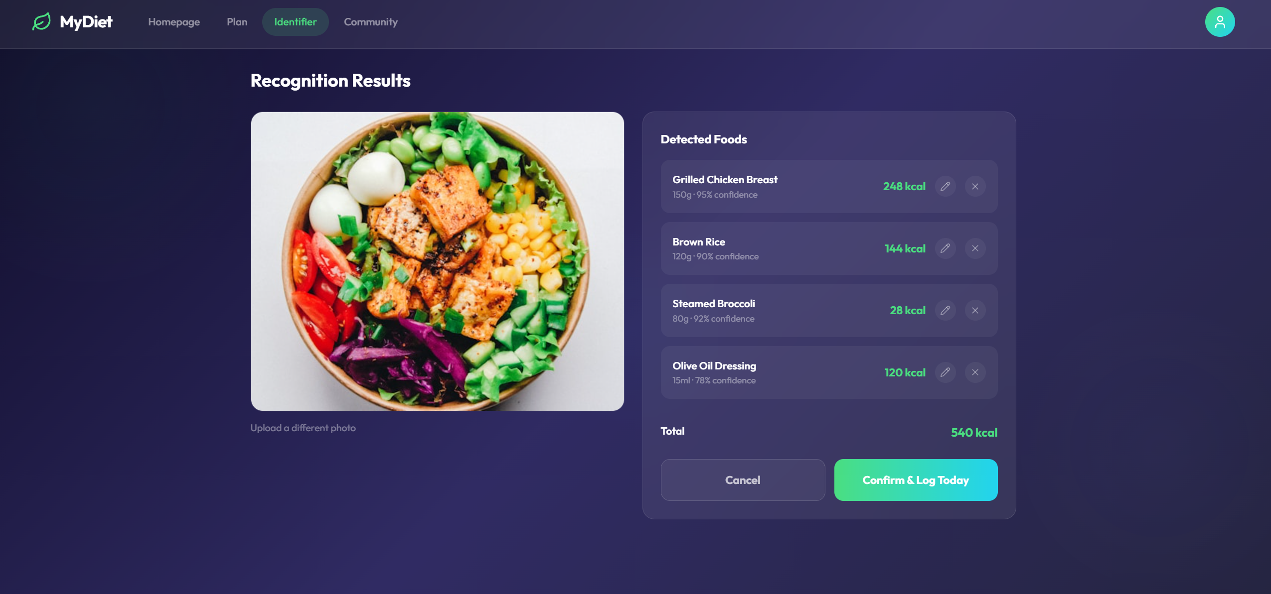

5.2.4 Edit or confirm results
Users can:
- Edit detected items
- Remove incorrect items
- Review the total calorie count

5.2.5 Log the meal
Click “Confirm & Log Today” to save the meal.
Click “Cancel” to discard.

5.3 Key features
- Automatic food recognition from images
- Calorie estimation
- Editable results
- Quick logging

5.4 Notes and limitations
- Accuracy depends on image quality
- Complex dishes may not be fully identified
- Users should review results before confirming

6. Community Feature

6.1 Overview
The Community feature allows users to interact with others, share experiences, and gain support during their health journey.

6.2 Accessing the Community
- Log in
- Click the “Community” tab
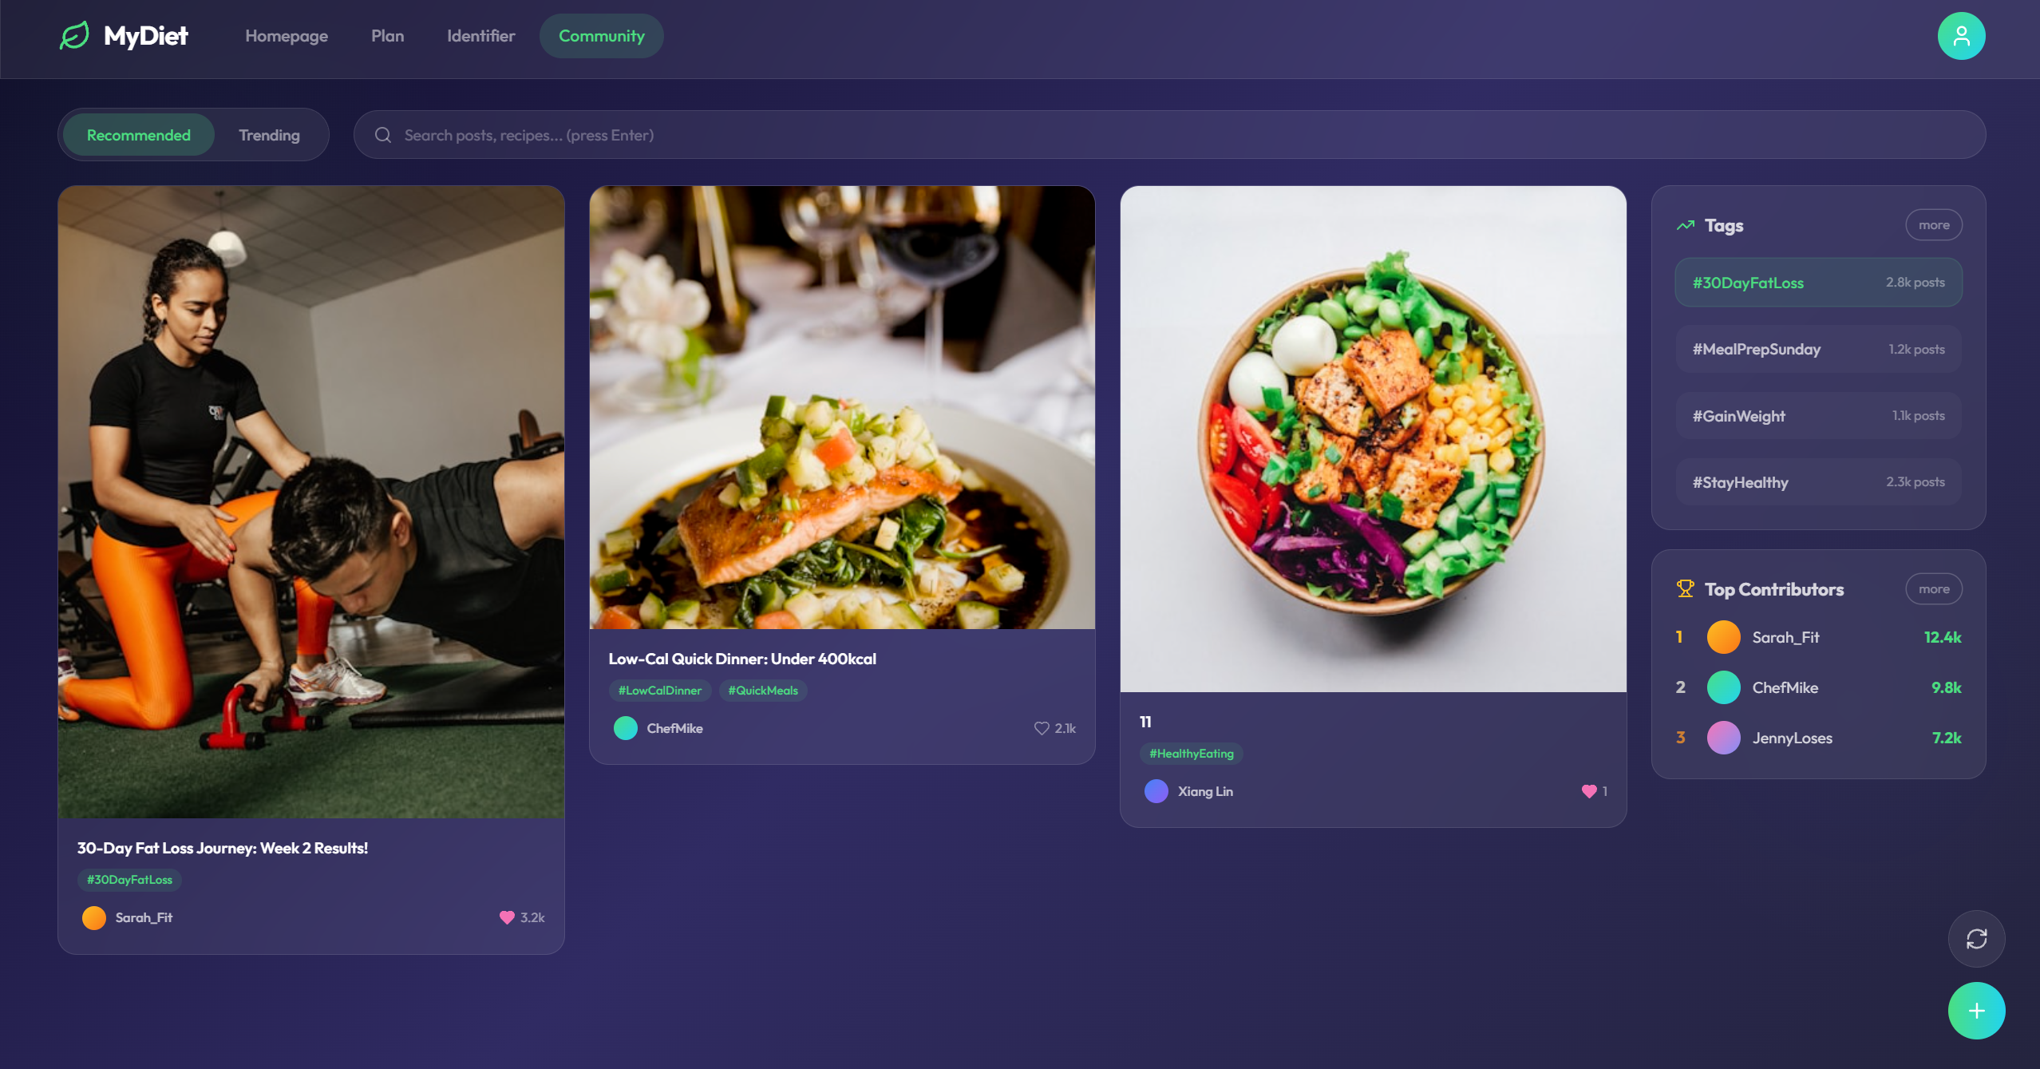

6.3 Browsing posts
Users can:
- View Recommended posts
- View Trending posts
- Use the search bar
- Explore tags

6.4 Viewing post details
Click a post to open full view:
- Full content
- Image
- Comments
- Likes
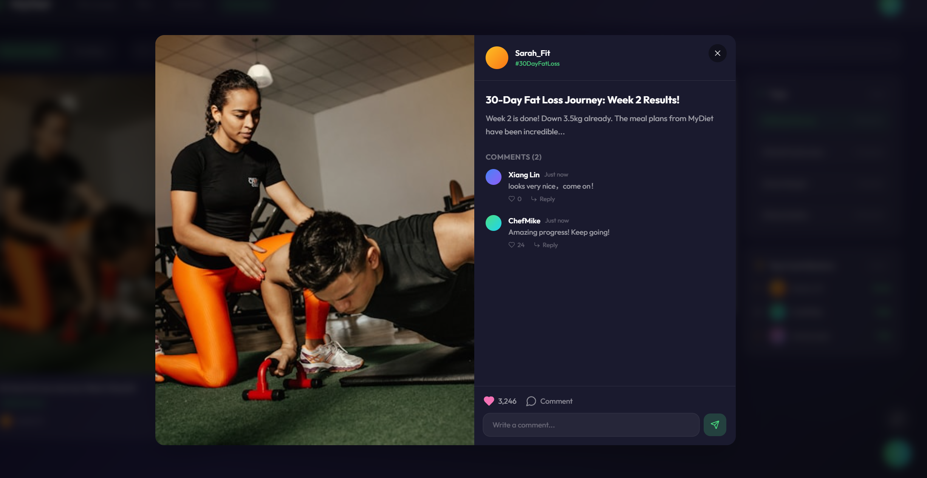

6.5 Interacting with posts
Users can:
- Like posts
- Comment
- Reply

6.6 Creating a post
- Click the “+” button
- Add content and images
- Add tags
- Submit
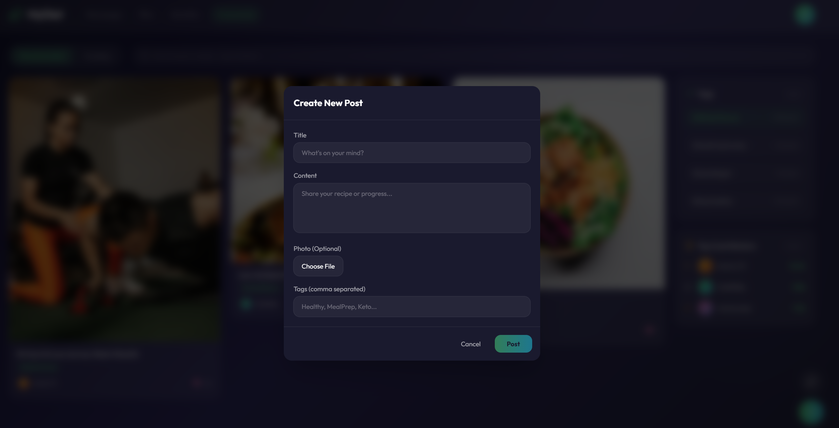

6.7 Tags and contributors
- Tags help categorize content
- Top contributors show active users

6.8 Benefits of the community
- Share experiences
- Gain motivation
- Learn from others
- Build healthy habits

6.9 Notes
- Follow community guidelines
- Avoid inappropriate content
- Respect others

